Title
(Oral o poster contribution)
Author #1 ^{a,b}, Presenting Author ª, Author #2 ^{c}, Author #3 ^{a,b}….
ª Affiliation #1
^{b} Affiliation #2
^{c} Affiliation #1

* presenting_author@email.com

Abstracts are brief summaries of the overall goal of the research, showing the specific ideas or concepts that will be presented, including outcomes and implications for practice. Please use ARIAL 10 as Font and size.
Authors: underline and use bold letters for the presenting author. Names with initials, complete surname.
Please limit abstracts to one single page. Do not change page layout
Include maximum 1 images with your abstract (limited to a third of the page length).
References are optional but encouraged. Please limit references to the 5 most pertinent citations at the end of the document. Refer to them with a number between brackets.
Notification of acceptance will be done to the presenting author email address.
Abstracts must be submitted by e-mail to asturfyt25@gmail.es in Word format. In the subject of the email should be indicated the type of contribution (oral or poster).
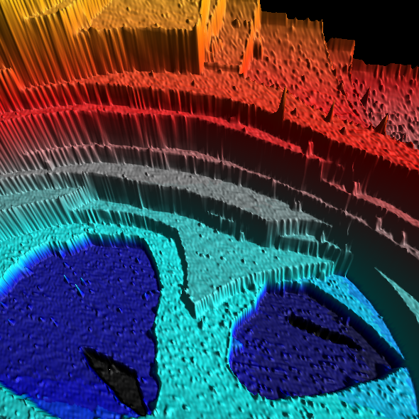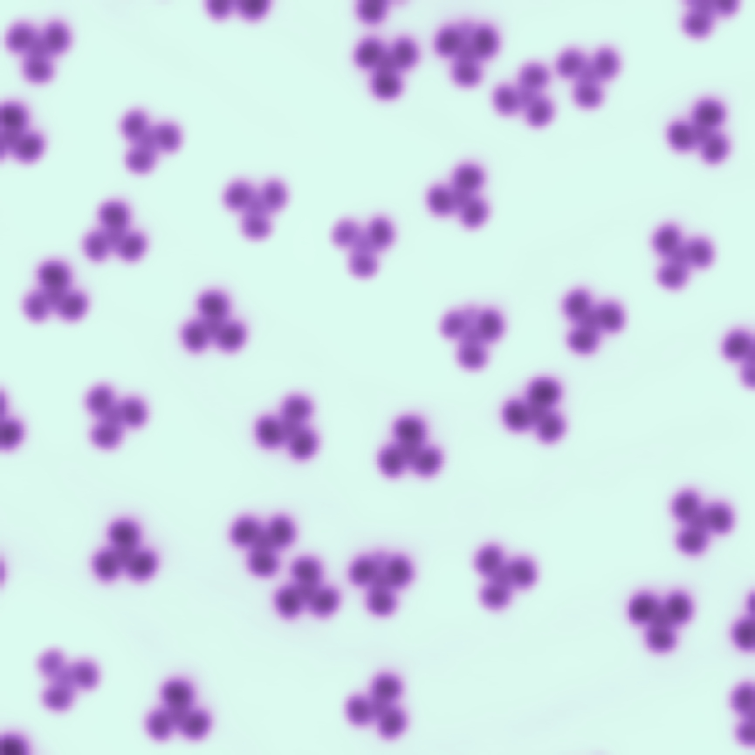
Figure - Description of the image
References
[1] Authors, Journal, vol, pag (year)

